LOVE PUlse Energy | mentored by:  David Paul

Love Pulse Energy is a new form of energy I have been working with for the last couple of months.
This energy is directly mentored by me with the student online and through email.
It is best to email me at David@ReikiAccess.com
I recommend that you have access to my website ReikiAccess.com
You must be a Usui Reiki Master/Teacher to begin the process to receive this attunement.
Preparation is done in stages:
- View the Movie “The Power of the Heart” see Resources on ReikiAccess.com

- Join my Facebook Page “Power in the Heart” see Resources on ReikiAccess.com and view all images

- Listen in Meditation from the website “Life Flow” see Resources on ReikiAccess.com we will work at aligning you to the vibrational energy of mother earth

- Take “The Chakra Test” see Resources on ReikiAccess.com to find if there are any of your chakras out of balance. We will work at balancing them and ask that you join the yahoo group “Reiki Rainbows” to help all chakras to be cleared and balanced.

- Attunement done

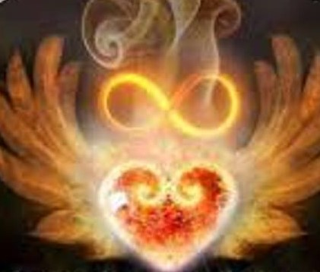
First symbol that is placed in your heart when attuned to the energy by David Paul
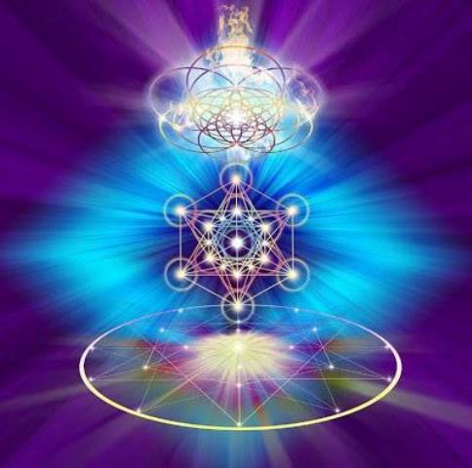
2nd symbol shows the pulse of the energy from your heart out into the world or a particular person rising upward in a pulse like flow

